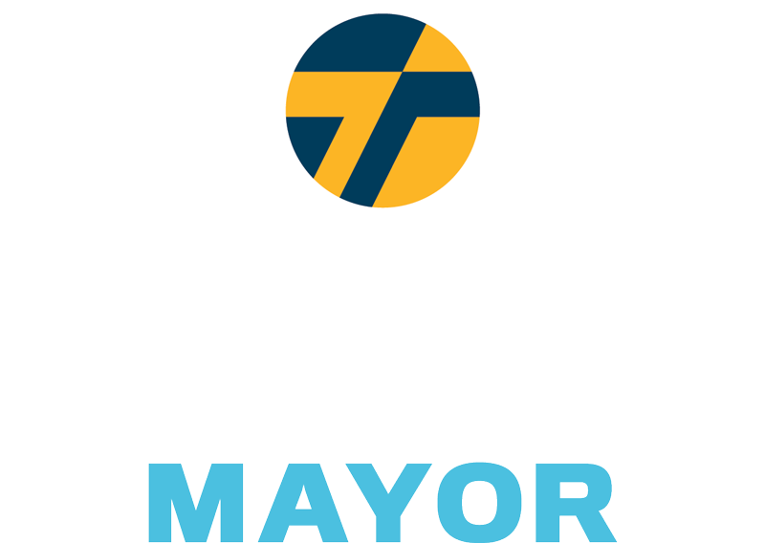

Bending the Curve on Racial Health Disparities During the COVID-19 Crisis

The COVID-19 global health crisis has exposed stark disparities in health care across Baltimore. Thiru believes everyone is entitled to equitable resources and health care, especially in times of incredible need and uncertainty. Here's his five-point plan to adress racial disparities in COVID-19 testing and treatment.

Increase Testing & Drop Referral Requirement for at-risk Populations

Right now, you must have a doctor's referral to be tested for COVID-19. Access to doctors is not universal. To protect at-risk populations, the doctor referral requirement should be lifted for anyone over the age of 50 living in the hardest hit neighborhoods, like 21215.

House Essential Workers in Hotel Rooms for Self-Isolation

Essential workers who are unable to isolate themselves at home should be offered free, alternative housing at hotels and motels for a 14-21 day period. Priority should be given to residents living in zip codes deemed to be COVID-19 hotspots.

Partner with Community Leadership and Prominent Health Care Institutions

Baltimore is home to world-class medical research facilities and hospitals. To ensure that communities that need increased testing receive the resources and treatment they need, City Hall should join our medical institutions in strategic partnerships with non-profit organizations, faith communities, and volunteers already well-established and connected on the ground.

Halt Non-Essential Demolition and Construction in COVID-19 Hotspots

Following the lead of New York and Boston, Thiru is calling for the suspension of all non- essential construction and demolition projects. Exceptions should be approved through the submission of an Essential Construction request.

Establish Modern Healthcare Infrastructure in Disconnected Communities

Thiru will partner with philanthropic organizations to provide internet and computer access to public housing units. The pandemic has revealed the importance of telemedicine infrastructure that allows patients to immediately and conveniently communicate with care providers.

Close the Medicaid and Private Health Insurance Gap

Lack of insurance forces individuals to make impossible decisions between financial security and health care. Thiru plans to restructure our insufficient insurance coverage by providing year long, city-backed medical grants to all uninsured adults that do not qualify for Medicaid coverage due to income limits.



**Beyond Data: Bending the Curve on Racial Health Disparities During the COVID-19 Crisis**

It is now clear that people of color will be infected and pass away from COVID-19 at higher rates in the United

States. Nowhere will that be more acute or obvious than in America’s cities. Here in Baltimore, city politicians

have been slow to act. Tracking the evidence will confirm for posterity what we already know, that communities

of color will be ravaged by this public health crisis just as they are disproportionately impacted by most public

health threats. We have to do better. City Hall must take drastic action to protect its citizens now and to address

the growing inequity in health care access.

In cities across the U.S., African-Americans and people of color account for a significantly higher percentage

of coronavirus deaths than their corresponding population share. Black Chicagoans are dying at six times the

rate of their white neighbors, with 68% of deaths being Black individuals who make up only 30% of Chicago’s

population. African-Americans are only 32% of Louisiana’s population; yet they are 70% of known coronavirus

deaths. Baltimore's population is 62% Black. We know that Baltimore is at risk of, if not already victim to, the

same disproportionate outcomes along racial lines.

Thiru is imploring city leadership to implement the following initiatives to help reduce coronavirus cases and

related fatalities, particularly among black and brown communities, now, and to overhaul the longstanding

inequities and systemic disinvestment that places them at higher risk. Specifically, Thiru proposes four near-

term solutions and three initiatives looking towards the horizon.

**To address immediate health care disparities in the fight against coronavirus, Thiru proposes:**

1. **Eliminating the Health Care Professional Referral Requirement for Testing**

Currently, individuals need a referral from a health care professional to receive a test for COVID-19. The

Maryland Health Department reported that 94% of COVID-19 related deaths, 284 of 302 as of April 14, were

individuals 50 and above. To further protect our most at-risk population, the health care professional referral

requirement should be suspended for Baltimore City residents who are over 50. Mass-testing is the only viable,

immediate solution to identifying and isolating individuals who are infected to prevent further spread of the

virus to vulnerable populations.

1. **Halting Non-Essential Demolition and Construction**

Non-essential demolition and construction work not only increases the potential for workers to contract

COVID-19, it can also cause respiratory problems for nearby residents with underlying health conditions. Cities

such as New York and Boston have already suspended all non-essential demolition and construction sites.

Following their lead, Baltimore should suspend all non-essential construction and demolition projects.

Exceptions will need to be approved through the submission of an Essential Construction request.

1. **Housing Essential Workers in Hotel Rooms for Self-Isolation**

Based on employment data by demographic, African-American employment is concentrated in essential

services. Four industries account for 63% of all jobs for African-Americans in Baltimore: retail trade;

transportation and warehousing; health care and social assistance; and administrative and waste management

services. We do not know the exact racial breakdown for essential employees. However, based on the sectors

that have been deemed necessary, including health care services, waste management services, transportation,

grocery stores, warehousing, and select retail stores, it is likely that African-American and Hispanic

Baltimoreans are subject to increased exposure to COVID-19. We must protect these individuals, who are

providing essential services, from unnecessarily contracting this virus.

Essential employees need the ability to self-isolate to protect their families and reduce the likelihood they

contract or spread COVID-19. Self-isolation requires individuals to have a single-occupancy room in their

home or place of residence. Following New York City’s lead, residents considered essential workers who are

unable to isolate themselves at home should be offered free, alternative housing at hotels and motels for a 14-

21 day period. Alternative accommodation should be allocated by priority based on the following: the number

of individuals at-risk of exposure in their household; if the individual lives in a zip code deemed to be a COVID-

19 hotspot; and, whether or not the individual is a member of a vulnerable or at-risk population.

1. **Increasing Testing Capacity Using Strategic Partnerships**

Baltimore is home to world-class hospitals and health research facilities. We must work with these institutions

to expand testing capacity and establish equitable distribution of resources. University of Maryland School of

Medicine, in partnership with University of Baltimore, is launching a state-funded, large-scale testing plan to

test 20,000 people per day. This will currently take months to ramp up.

To ensure communities receive resources and treatment, our medical institutions and City Hall must strategically partner with non-profit organizations, faith centers, and volunteers already well-established and connected on the ground. Particularly for low income individuals without access to private transit, some may only receive treatment at the most severe stages of their infection.

Developed partnerships will also facilitate distribution of accurate information and COVID-19 tests through pop-up centers, adequately staffed for screenings, in transit deserts and hotspots. If we are unable to safely transport potential vectors to testing locations, we must directly bring the resources to hotspot locations.

**Health care disparities will not vanish when the current pandemic abates. To restructure how Baltimore treats health needs, Thiru proposes:**

1. **Providing Access to Telemedicine Infrastructure**

Thiru has pledged to guarantee free, universal access to high-speed wifi across the city. We know families need access now, and the digital divide leaves disinvested neighborhoods at a further disadvantage -- this was true prior to this crisis, emboldened during COVID-19, and, if we do not act now, will remain a reality for years to come. City Hall will partner with philanthropic organizations to provide internet and computer access to all public housing units. The current pandemic has revealed the importance of telemedicine infrastructure that allows patients to conveniently communicate with care providers. Telemedicine eradicates transit barriers to visiting a professional and enables real-time assessment of health issues, in turn enabling quick action to treat serious concerns. Investing in digital infrastructure will also create overarching benefits to public health by allowing children to remain engaged with their education, granting access to information and news updates, and eliminating barriers to job and assistance program applications.

1. **Launching Health Intervention Program in Collaboration with Faith Communities**

Addressing entrenched health care disparities requires collaboration between the public sector and community stakeholders. The Mecklenberg Health Department demonstrated this expertly with their Village HeartBEAT program, which facilitates fun, healthy competition amongst faith based congregations to improve health metrics. In addition to competition on health indicators such as weight, exercise, tobacco use, and dietary choices, the program trains community awareness ambassadors and connects members to health services. Establishing a network in Baltimore that both encourages daily changes to improve health and identifies need for additional information and services would benefit people who have historically faced insurmountable barriers to health care.

1. **Expanding Medicaid Coverage for the Uninsured**

Testing and treatment for COVID-19 may cost up to $73,000 out-of-pocket for individuals without health insurance. According to the 2020 American Census, approximately 6.4% of Baltimore City residents under the age of 65 do not have medical insurance coverage. A global pandemic only exacerbates the existing health care inequities in our communities and victimizes those with pre-existing conditions, which occur at higher rates in minority populations. City leadership should embrace this opportunity to restructure our insufficient insurance coverage in Baltimore City by providing year long, city-backed medical grants to all uninsured adults that do not qualify for Medicaid coverage due to income limits. The Affordable Care Act provides subsidized health insurance for individuals from 100-400% of the Federal Poverty Line. These grants would provide the balance of the health insurance cost under the Affordable Care Act for those who are not covered by Medicaid. These grants can be renewed for the duration of the crisis, and/or until the recipient obtains employee-sponsored coverage or can independently afford insurance coverage.

Paid for by Thiru Vignarajah for Baltimore Tunji Williams, Treasurer

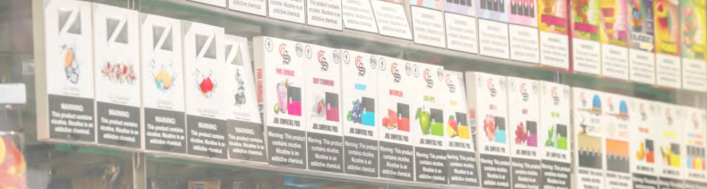

"Vignarajah’s aggressive plan to stop JUUL and the other tobacco companies will put Baltimore at the forefront of protecting the public from the dangerous and addictive e-cigarettes that are expanding the tobacco epidemic.”



*ENDING THE E-CIGARETTE EPIDEMIC*

Baltimore will ban flavored tobacco products including e-cigarettes

As the FDA and CDC have cautioned, flavored vaping and tobacco products, like cigarillos and menthol cigarettes, present a grave health risk, particularly to children. It is no accident the use of e-cigarettes and vapes among young people has exploded, as 7 out of 10 teens are exposed to e-cigarette ads. Major e-cigarette makers are pushing colorful tobacco products, using mobile platforms like YouTube and Twitter, and promoting teen-friendly flavors. Already, 10% of high school students use e-cigarettes—and more than

60 toxins have been identified in liquid flavored products. Baltimore should follow cities from San Francisco to Chicago to Minneapolis, which have prohibited flavored products to protect their citizens and children.

Enact complete prohibition of e-cigarettes in indoor public spaces

The CDC has reported that e-cigarettes not only contain nicotine, but also have lead, nickel, tin, volatile organic compounds, and diacetyl, a chemical linked to a serious lung disease. Secondary aerosol inhalation increases the risks of asthma in young children, sudden infant death syndrome, and respiratory symptoms and infections. Baltimore should build on its partial indoor prohibition, close the loopholes, and forbid smoking of e-cigarettes in all places cigarette smoke is banned, including bars and restaurants.

Initiate city lawsuit against e-cigarette manufacturer JUUL

New York City and DC recently filed major lawsuits against JUUL for illegally targeting youth and intentionally misleading consumers about the consequences of its products. According to the CDC, a single JUUL or e-liquid pod contains the same amount of nicotine as roughly 20 packs of cigarettes. Just as we sued drug companies for fueling the opioid crisis, Baltimore should join the movement of cities suing this industry for creating the latest youth health crisis.

Impose tax on e-cigarettes to fund children’s health screenings at city elementary schools

Like neighboring locales, Baltimore should impose a 50% wholesale tax on vaping products (between Montgomery County’s 30% and DC’s 96%), plus an additional $0.10/mL tax on e-liquids containing nicotine. The tax proceeds would pay for comprehensive health screenings of city elementary school children, as well as youth prevention efforts and treatment for those addicted.

Keep tobacco money out, refuse campaign donations from industry and lobbyists

Our campaign pledges to refuse political donations from tobacco and e-cigarette companies, as well as from their executives and lobbyists. The tobacco industry has made significant contributions to Baltimore leaders in order to block regulations that would protect our children from their harmful products. Citizens deserve to know that their health and safety comes first, not campaign finances and industry profits.

***“I want Baltimore to become the most inviting and hospitable city in the country for the LGBTQ+ community. No one should be judged for who they are or who they love. As a city, our policies, practices, and institutions must reflect that commitment.”***

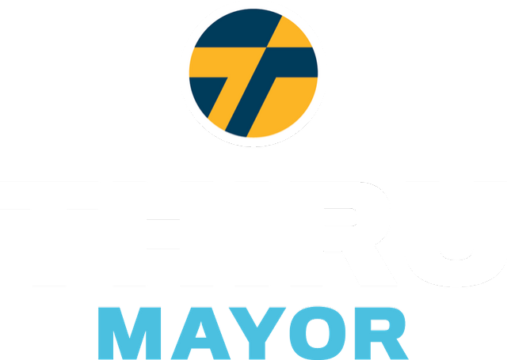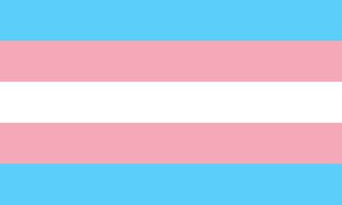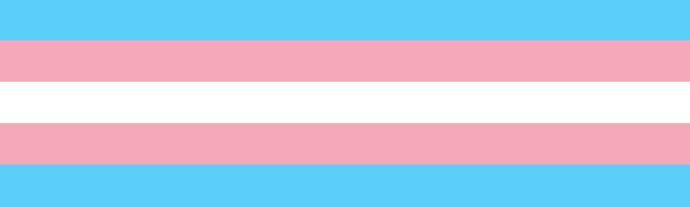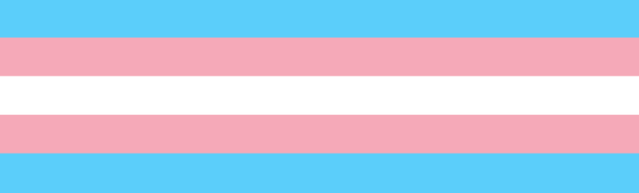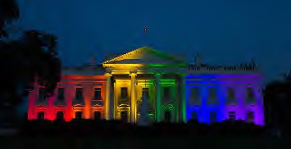

#### Thiru's policy framework for fighting discrimination and protecting the civil rights of LGBTQ+ citizens in Baltimore:

1. Promote LGBTQ+ owned small businesses, entrepreneurs, and city districts
2. Enable services to account for challenges facing LGBTQ+ youth in Baltimore
3. Prioritize inclusive workplace policies and trainings for all city employees
4. Appoint an official LGBTQ+ Liaison within the Mayor’s Executive Office
5. Address the needs of at-risk LGBTQ+ populations including veterans and seniors
6. Protect transgender citizens from crime and discriminatory police enforcement
7. Improve and expand health services for members of the LGBTQ+ community Broaden LGBTQ+ Commission’s responsibilities to include training and privacy- sensitive data collection for evidence-based policy making

8

Thiru, an advocate and ally, led the drafting of a report by the Maryland Attorney General, *The State of Marriage Equality in America*, which was cited by the Supreme Court in its landmark decision, *Obergefell v. Hodges.*



**Vignarajah Declares Solidarity, Announces Plans to Make Baltimore Most Inviting City in America for LGBTQ Community**

Our city has a vibrant and proud LGBTQ community. Thiru is dedicated to safeguarding their rights and fostering diversity and inclusivity within Baltimore. While Baltimore has made progress, members of the LGBTQ community continue to face systemic discrimination with regard to healthcare, housing, education, and employment, as well as in their day-to-day lives in the forms of stigmatization and outright violence. Thiru stands as a proud ally to the LGBTQ community and will work with local leaders to promote policies that account for the reality that discrimination manifests itself differently depending upon race, sexual orientation, and gender identity.

Thiru’s policy framework will focus on a range of issues important to Baltimore’s LGBTQ community

and aim to break remaining barriers to full equality, including:

1. Promote LGBTQ-owned small businesses, entrepreneurs, and city districts
2. Enable services to account for challenges facing LGBTQ youth in Baltimore
3. Prioritize inclusive workplace policies and trainings for all city employees
4. Appoint an official LGBTQ Liaison within the Mayor’s Executive Office
5. Address the needs of at-risk LGBTQ populations including veterans and seniors
6. Protect transgender citizens from crime and discriminatory enforcement
7. Improve and expand health services for members of the LGBTQ community
8. Broaden LGBTQ Commission’s responsibilities to include training and privacy-sensitive data collection for evidence-based policy making
9. **Promote LGBTQ-owned small businesses, entrepreneurs, and city districts**

Baltimore must invite small businesses and create business alliances across the board. That said, it can take steps to specifically assist and accommodate local LGBTQ-owned businesses as well. Thiru will incorporate LGBTQ-owned businesses into the incentive programs that function through the Office of Minority and Women-Owned Business Development, in order to rightfully acknowledge their role in providing services to the citizens of Baltimore and in creating a more inclusive, diverse space for community. Building on residential and commercial districts that serve and celebrate LGBTQ culture, Thiru will also prioritize city and private investment in welcoming, inclusive neighborhoods.

1. **Enable services to account for challenges facing LGBTQ youth in Baltimore**

*Protecting LGBTQ Identities in Schools*

In April of 2019, the Baltimore City Board of School Commissioners passed [Policy JBB](https://www.osibaltimore.org/2019/04/baltimore-city-school-board-passes-policy-to-protect-trans-students/), which ensures that transgender students have access to the restrooms of their preference and are referred to by the right gender/pronouns in class and on official documents and records. To make Baltimore’s public schools even more inclusive, Thiru will establish LGBTQ-inclusive curriculum and support LGBTQ youth anti-harassment campaigns.

*Catering Homeless Shelters to LGBTQ Youth*

According to a recent study, roughly [40%](https://nationalhomeless.org/issues/lgbt/) of the homeless youth population in the United States identify as LGBTQ. Thiru will employ the Mayor’s Office of Human Services to equip Baltimore’s pre-existing homeless shelters, along with transitional and supportive housing, with the resources to best serve LGBTQ youth, such as increased counseling staff, tailored job training, and access to health services.

*Founding a LGBTQ drop-in center*

The Department of Health and Human Services shows that LGBTQ individuals are far more likely to experience clinical depression and are roughly three times more likely to complete suicide. For these reasons, [New York City has just pledged 4.8 million dollars to opening a new 24 hour drop in center](https://www.aliforneycenter.org/programs/drop-in/) [for LGBTQ youth.](https://www.aliforneycenter.org/programs/drop-in/) Baltimore should follow the example of other cities and create its own drop-in center. The center would unite resources and actors, like schools and community organizations, around our LGBTQ youth.

1. **Prioritize inclusive workplace policies and trainings for all city employees**

Discrimination in the workplace is an unfortunate reality for many in the LGBTQ community. Baltimore City Agencies must take proactive steps to combat prejudice against their employees. In an effort to increase accountability and establish a welcoming, respectful environment for LGBTQ employees, Thiru will implement mandatory and recurring inclusivity training for city employees, beginning with new hires. The city’s existing LGBTQ Commission will head training efforts. In addition, Thiru will require there to be at least one gender-neutral bathroom in all city-owned buildings and adjust city government forms to include gender neutral language and non-binary identities.

1. **Appoint an official LGBTQ Liaison within the Mayor’s Executive Office:**

To increase the awareness of LGBTQ issues within the mayor’s executive office, Thiru will establish an official LGBTQ Liaison. The LGBTQ Liaison will convene with community members, local organizations, and relevant city entities to learn about the issues that Baltimore’s LGBTQ people face every day. The liaison will review city policies and services, communicate to government leaders when proposals fail to meet standards for LGBTQ equality, and serve as a resource for constituents who want to bring LGBTQ-related issues to city government but hesitate in fear of dismissal or misunderstanding. The appointed individuals would collaborate alongside the city’s existing LGBTQ Commission, its selected Chairperson, as well as the Liaison Officer within the Baltimore City Police Department.

1. **Address the needs of at-risk LGBTQ populations including veterans and seniors**

[Veterans who identify as LGBTQ face increased health risks and unique challenges in health care.](https://www.baltimoresun.com/health/bs-hs-elderly-lgbt-20150927-story.html) Thiru will lead Baltimore in conjunction with the Veterans’ Commission to collect data on LGBTQ veterans and provide them with the appropriate health benefits and services. He will also employ legal experts to aid veterans who were wrongfully subject to discrimination during service or the “Don’t Ask Don’t Tell” policy upon discharge.

Thiru will also strive to aid Baltimore’s LGBTQ population, who are more prone to health issues and suffer from rising housing costs. He will prompt the LGBTQ Commission and LGBTQ Liaison in the Executive Office to advocate on behalf of the senior LGBTQ population, push for affordable housing options, and inform senior-care facility managers, employees, and residents of relevant anti-discrimination laws.

1. **Protect transgender citizens from crime and discriminatory enforcement**

The nationwide surge in violent hate crimes against the transgender community is both heartbreaking and unacceptable[.](https://www.hrc.org/blog/hrc-mourns-tydi-a-black-transgender-woman-killed-in-baltimore) [Baltimore has seen multiple incidents of transphobic related violence.](https://www.hrc.org/blog/hrc-mourns-tydi-a-black-transgender-woman-killed-in-baltimore) Thiru will work with the LGBTQ Commission Chairperson, the LGBTQ Liaison to the Executive Office, and LGBTQ Liaison Officer to bolster relationships between law enforcement and the transgender community. Further measures include 1) requiring the LGBTQ Officer to submit statistics and reports on LBGTQ-related crimes to the Mayor’s Office, 2) monitoring the Police Department’s fulfillment of and training related to [Policy 720](https://www.baltimorepolice.org/sites/default/files/Policies/720_Lesbian_Gay_Bisexual_And_Transgender_Involved_Incidents_0.pdf) [(2018 draft here](https://www.powerdms.com/public/BALTIMOREMD/documents/349766)) and 3) incorporating recruitment of LGBTQ individuals into Baltimore’s police force within crime policy proposals and halting discriminatory practices such as unnecessary trespass and loitering arrests.

1. **Improve and expand health services for members of the LGBTQ community**

*Mental Health*

[LGBTQ individuals, especially youth, are more than twice as likely to suffer from a mental health](https://www.psychiatry.org/File%20Library/Psychiatrists/Cultural-Competency/Mental-Health-Disparities/Mental-Health-Facts-for-LGBTQ.pdf) [condition compared to non-LGBTQ identifying individuals.](https://www.psychiatry.org/File%20Library/Psychiatrists/Cultural-Competency/Mental-Health-Disparities/Mental-Health-Facts-for-LGBTQ.pdf) Thiru will provide more accessible and affordable mental health services tailored to the LGBTQ community under a new mental health program within the Baltimore City Health Department. This initiative will create a new LGBTQ- specific mental health hotline and foster partnerships with school counselors and youth centers/organizations to provide mental health resources where currently insufficient.

*Appropriate/Inclusive Treatment and Care*

Often a doctor’s office can be an uncomfortable and vulnerable space for LGBTQ individuals. Thiru will encourage efforts to provide inclusive medical care to members of the LGBTQ community, following models similar to Johns Hopkins’ “Embracing the Rainbow” program. These initiatives will encourage respectful communication between LGBTQ patients and medical professionals, and emphasize training focused on gender-neutral questioning and non-binary options to medical inquiries.

*Partnerships with Health Professionals*

Institutions such as the Baltimore City Health Department the Mayor’s Office of Human Services will partner with local healthcare providers, state and federal agencies, and community groups to promote LGBTQ health and foster efficient collaboration. Health issues such as HIV prevention and treatment will receive particular attention.

1. **Broaden LGBTQ Commission’s responsibilities to include training and privacy-sensitive data collection for evidence-based policy making**

In early 2018, Baltimore City passed an executive o rder to create a city-sponsored LGBTQ Commission, which comprises 15 community members who offer insights and recommendations to promote the prosperity of LGBTQ Baltimoreans. This executive order was a vital decision to further equality-driven policymaking, but there is more we can do to integrate and support the Commission. Thiru would expand its responsibilities, while ensuring access to required resources. The Commission would lead research on issues pertaining to the community and manage inclusivity and diversity training for city employees and external parties.

Too often we fail to collect LGBTQ specific data to inform the allocation of resources, rendering the massive disparities experienced by members of the LGBTQ community — particularly transgender people — invisible to policymakers. With the Commission’s help, Baltimore can study, investigate, and close the gaps in health, income, and well-being outcomes that the LGBTQ community experiences, collecting data that respects individual and community privacy. Involvement through government or third-party training, in schools or medical facilities, will heighten the Commission's visibility and fulfill an essential arm of community outreach.

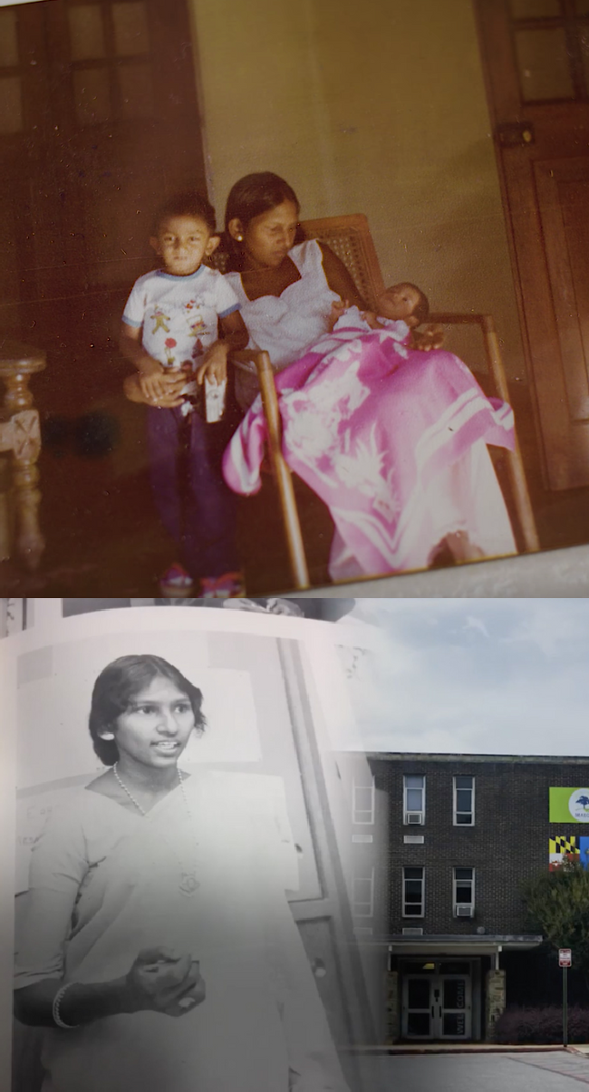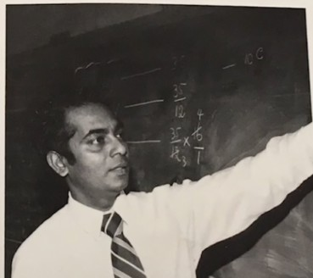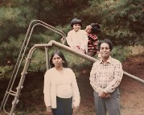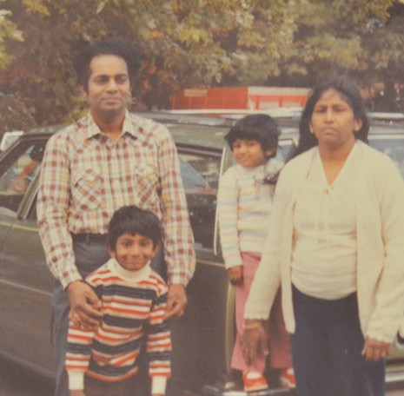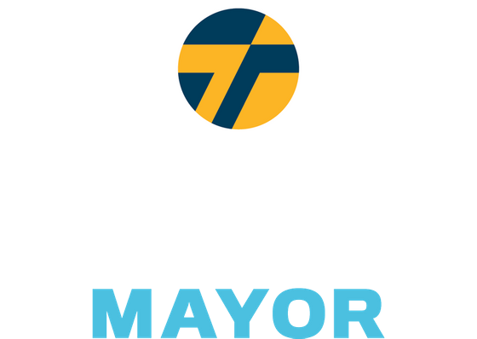

*Aspiring to become the most inviting and hospitable city in the country for immigrants and refugees, Baltimore should be the Plymouth Rock and Ellis Island of the next century."*

*Thiru's Plan to Safeguard & Support Immigrants*

Thiru's family fled a civil war and came to Baltimore when he was three. Both dedicated city school teachers, his mother taught at Poly and Morgan State, and his father taught at Edmondson, Douglass, Southern, and Western. His family's commitment to public service is not an unfamiliar story. Immigrants have always been an essential force in forging Baltimore’s vibrant culture and history. Thiru strives to make Baltimore welcoming to immigrants from all around the world: a place to raise their families, build a life, and call their home.

*This is not just the American Dream – it is the Baltimore Dream too.*

Guarantee Legal Proceedings & Right to Counsel

Amend the city charter to guarantee legal proceedings and a right to counsel, with a translator if neccessary, for those who face deportation

No Support for ICE

Promise no money or effort will be directed towards supporting ICE

Bar ICE from sensitive locations like places of worship, hospitals, and courthouses Encourage victims and witnesses to cooperate in human trafficking, violent crime, and domestic violence cases

Prioritize Civil Resolution & Recruit Immigrant Officers

Work with state government to direct police to pursue civil remedies/diversion options prior to arrest for non-violent offenses where deportation is a disproportionate response Recruit more immigrant police officers and remove bar on permanent residence

Invite Cultural Exchange

Hold events to celebrate Baltimore's immigrant populations Offer more affordable language classes for community members

Establish H-1B Visa Matching Program

Pair immigrant workers with local employers, non-profits, and municipal agencies

Heighten Representation & Outreach

Appoint liaisons/translators to speak to City Hall on behalf of community advisory boards

Improve coordination within the Mayor's office to offer consistent, quality, and easily- accessible resources to programs and information

Expand Municipal ID Program for Non-Citizen Residents

Broaden access to city-run assistance by providing valid ID to non-citizen residents Secure non-resident participation in decisions regarding the local school board

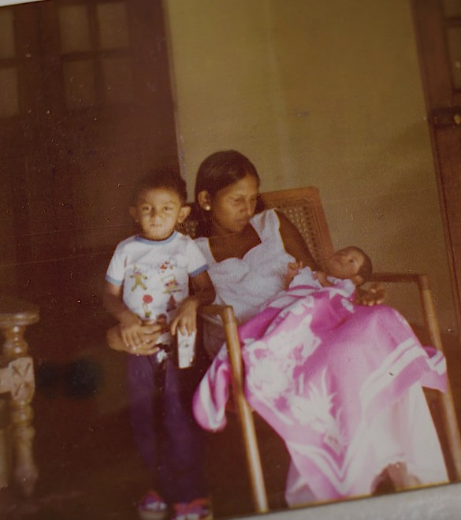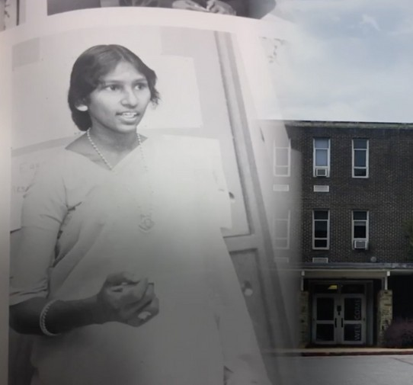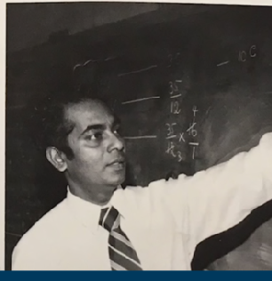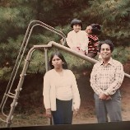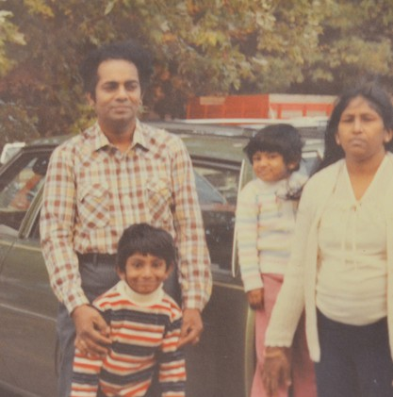

*Aspirando a ser la ciudad mas atractiva y hospitalaria en el país para los inmigrantes y refugiados, Baltimore debería ser el Plymouth Rock y Ellis Island del próximo siglo.*

*El Plan de Thiru para Asegurar y Auydar a los Inmigrantes*

La familia de Thiru escapó de una guerra civil y vino a Baltimore cuando él tenía tres años. Sus padres eran maestras dedicadas en la ciudad, su madre trabajó en Poly y Morgan State, y su padre trabajó en Edmondson, Douglas, Southern, y Western. El compromiso de su familia al servicio publico no es una historia desconocida. Los inmigrantes siempre han sido una fuerza esencial, forjando la cultura vibrante y la historia de Baltimore. Thiru se esfuerza para hacer de Baltimore una ciudad acogedora a los inmigrantes de todo el mundo: un lugar para crecer a la familia, construir una vida, y llamarlo hogar.

*No es simplemente El Sueño Americano, es El Sueño de Baltimore también.*

Garantizar Procedimientos legales y el derecho al consejo

Enmendar la Carta de la Ciudad para garantizar procedimientos legales y el derecho al consejo, con derecho a servicios de traducción, para aquellos en peligro de deportación.

No apoyo para ICE

Ni fondos ni esfuerzos serán proporcionados al ICE.

No permitir que ICE entre en locales sensitivos como iglesias, hospitales, y cortes.

Apoyar las victimas y los testigos a cooperar en casos de la trata de personas, de crimen violenta y de la violencia doméstica.

Dar prioridad al remedio civil & recultar policías inmigrantes

Trabajar con el gobierbo estatal para hacer que la policía recurra al remedio civil y desvío previo al arresto para las ofensas no violenta donde la deportación es una respuesta desproporcionada.

Contratar con mas inmigrantes para ser policía y quitar el requisito de residencia permanente

Invitar intercambio cultural

Tener eventos para celebrar la población inmigrante de Baltimore.

Dar mas clases de lenguaje económico para miembros de la comunidad.

Establecer un programa coincidente de H-1B Visa

Acoplar trabajadores inmigrantes con empleadores locales, las organizaciones sin fines de lucro, y agencias municipales.

Crecer la representación y programas de divulgación

Nombrar contactos y traductores para hablar con la alcaldía en los consejos consultivos de la comunidad

Mejorar la coordinación con la oficina del alcalde para dar recursos constantes, de calidad, y fácilmente accesible para programas y información

Ampliar el programa de identificación municipal para residentes no ciudadana

Ampliar el acceso a la ayuda de la ciudad dando identificación válida a los residentes no ciudadanos

Asegurar la participación de la gente no residente en las decisiones que afectan a las escuelas locale

*SQUEEGEEING ALTERNATIVE PLAN*

Squeegeeing emerges from the complex problems that have plagued Baltimore for generations: a lack of economic opportunity, unaccountability in our broken public schools, a sweeping opioid epidemic, and rampant crime that disproportionately affects Black and Brown communities. Getting individuals off the streets and into well-paying, stable jobs, as well as connecting them to the resources they need, will require a multifaceted, comprehensive approach.

Squeegee boys are not one monolithic group. These individuals have unique motivations and needs that prompt their decision to turn to squeegeeing. We see three distinct categories of individuals and realize each will require a personalized engagement strategy:

Those who squeegee to provide for themselves and their families

Victims of addiction, mental illness, or have backgrounds impacted by substance abuse

Those who are committed to squeegeeing regardless of diversion attempts

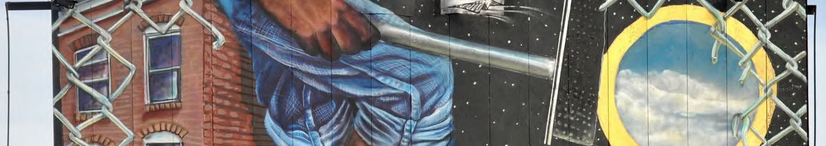

Open pathways for advancement in education or employment Provide health, addiction, housing, or job placement services Take the tools of their trade to raise the cost of doing business



**FROM SQUEEGEES TO SAFETY AND SUCCESS**

Squeegee boys have become, fair or not, a symbol of Baltimore’s current plight. To some, they are an unfortunate marker of a city led by complicit politicians and failing schools that do not provide people, youth especially, with meaningful job opportunities and career advancement pathways. For others, they represent a menacing presence that deters them from bringing their families downtown. At a different time in Baltimore’s history, these squeegee workers would not pose such a challenge to residents and elected officials. However, with record violence, they are an ever-present reminder that Baltimore’s leaders are failing to connect the dots and support the individuals who may need it most.

We know that interactions between drivers and squeegee boys can turn aggressive. In January 2020, we saw the heart-wrenching video of a man senselessly beaten by squeegee boys on the corner of President and Lombard. Not only do commuters feel threatened, but squeegee boys also put themselves into danger darting in between busy traffic. In October of 2018, a ten-year-old squeegee boy was injured after being struck by a car; in 1986, a fourteen-year-old squeegee boy was fatally hit by a vehicle. City Hall has yet to move the needle in a way that instills confidence that we can avoid another tragedy — we don’t need another incident to learn from our past.

Squeegeeing emerges from the complex problems that have plagued Baltimore for generations: a lack of economic opportunity, unaccountability in our broken schools, a sweeping opioid epidemic, and rampant crime that disproportionately affects black and brown communities. Getting individuals off the streets and into well- paying jobs, as well as connecting them to the resources they need, will require a comprehensive approach.

**Identify What Drives Individuals to Squeegeeing**

Squeegee boys are not one monolithic group. These individuals have unique motivations and needs that prompt their decision to turn to squeegeeing. Thiru and his team see three distinct categories of individuals and realize each will require a personalized engagement strategy:

1. Those who squeegee to provide for themselves and their families
2. Those who squeegee and are themselves struggling with addiction or mental illness or come from backgrounds impacted by substance abuse
3. Those who will attempt to continue squeegeeing regardless of diversion attempts

Baltimore’s existing programming and services are disjointed and do not sufficiently provide the wraparound care that will lead to sustainable outcomes. To best engage with squeegee workers, we need to personally meet them where they are. Squeegeeing is limited to the few corners with the highest traffic volume. Our team went to the street corners, collected anecdotal evidence, and spoke with these young people, realizing that squeegeeing primarily occurs on fourteen corners:

**Map of Top Squeegee Locations as identified by the Thiru for Baltimore Team**

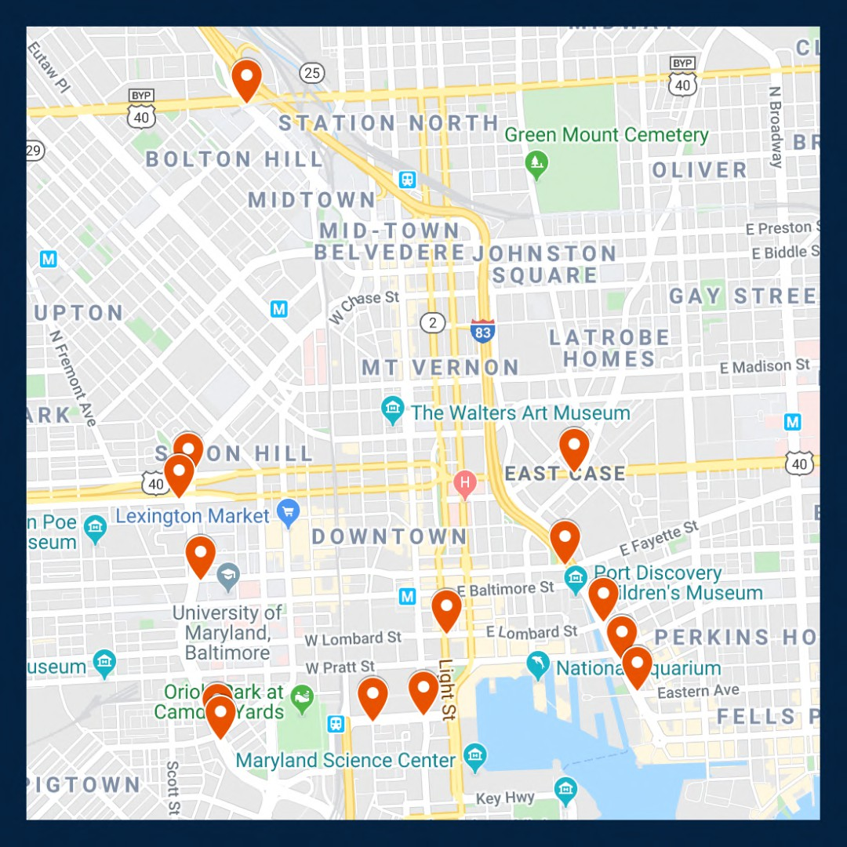

As mayor, Vignarajah pledges to:

1. Ensure squeegee boys are aptly connected to pathways to advance their education or gain secure employment with advancement opportunities
2. Recognize squeegee boys with addiction, mental illness and/or homelessness limitations that require health, addiction, housing, or job placement services and promptly facilitate access to those programs
3. In unique cases, where individuals will continue to turn to squeegeeing regardless of alternative options, take the tools of their trade to raise the cost of doing business

**Create Alternative Work Programs that Compete with the Benefits of Squeegeeing**

*Facilitate Job Interviews Between Squeegee Boys and Local Businesses*

City leaders cannot pretend that creating a stable nine-to-five job that pays $15 an hour, before taxes, can ever compete with the perks of being a squeegee boy. We must acknowledge that they can in some instances make

$30 to $50 an hour, can come and go as they please, and report to no one but themselves. Nevertheless, we must present an alternative employment opportunity that is attractive to these young people.

Thiru has already started partnering with local businesses to provide squeegee boys with secure employment and in turn, advancement opportunities. Thiru will hire liaisons to assist squeegee boys interested in pursuing a stable, permanent career and connect them with local businesses that are willing to offer employment. While meaningful employment may present new challenges to these individuals, it can teach valuable skills, such as how to build a schedule, how to remain accountable to a team, how to build a relationship with a supervisor, and how to follow codes of conduct. The greatest opportunity provided by employment in local businesses is upward mobility. These opportunities will open an avenue for progression otherwise difficult to obtain for many of these young men, and certainly not available on a street corner.

We have refused to wait for city politicians to take action, or even for the election, to implement a program that can provide immense benefits for our economy and these young men. Squeegee boys and local businesses interested in participating should email [opportunity@thiru2020.com.](mailto:opportunity@thiru2020.com)

**Station Unarmed, Site-Specific, Deputized Community Liaisons at the Busiest Corners**

*Bring Resources to Street Corners*

Deputized community liaisons will positively interact with squeegee boys in their designated zone, building relationships and trust. Liaisons will not take away resources from our struggling police force -- instead, these liaisons will receive specific training on de-escalation techniques, and curate a specific policy for positive and appropriate engagement with squeegee boys.

Part of this positive engagement will include identifying school-aged individuals, in partnership with the relevant schools and after-school employment or programming, where applicable, who should be required to return to their education. Each deputized liaison will receive access to point contact information for all middle and high schools in Baltimore City. The City can encourage and support heightened collaboration between the liaisons and educators/administrators to redirect these young squeegee boys back to the classroom, while making sure their needs are met and they have the guidance, resources, and support to thrive.

These deputized community liaisons would also be trained on identifying vulnerable individuals in need of social services and City programs. They will receive training on recognizing who is suffering from food insecurity, addiction and mental illness, or housing troubles, so as to connect those individuals to appropriate experts and resources. This will take the form of Seattle’s Law Enforcement Diversion Programs (LEAD) which provides a credible alternative to booking individuals with behavioral health needs for low-level offenses. Instead of creating criminal entanglements, LEAD diverts these individuals to community-based interventions including housing, addiction, mental illness and health services.

*Raise the Cost of Doing Business*

Baltimore’s squeegee boys are making calculations on how to make ends meet. Some will not be receptive to alternative job opportunities because of the lucrative cash flow squeegeeing provides. That being said, we need to change the calculation by not only introducing consistent and favorable options for skill development and upward mobility, but also by increasing the cost of doing business in the streets by confiscating the tools of their trade. In accordance with the Baltimore City Code and working in conjunction with Community Liaisons; site-specific, unarmed private security guards who have been temporarily granted limited policing power will have the ability to confiscate squeegees. They will have no authority beyond their stationed corners, but this narrow power will raise squeegee boys’ opportunity costs. Article 19, Section 47-4 of the code grants police the authority to restrict solicitation “from any operator or occupant of a motor vehicle that is in traffic on a public street, whether in exchange for cleaning the vehicle’s windows or otherwise.”

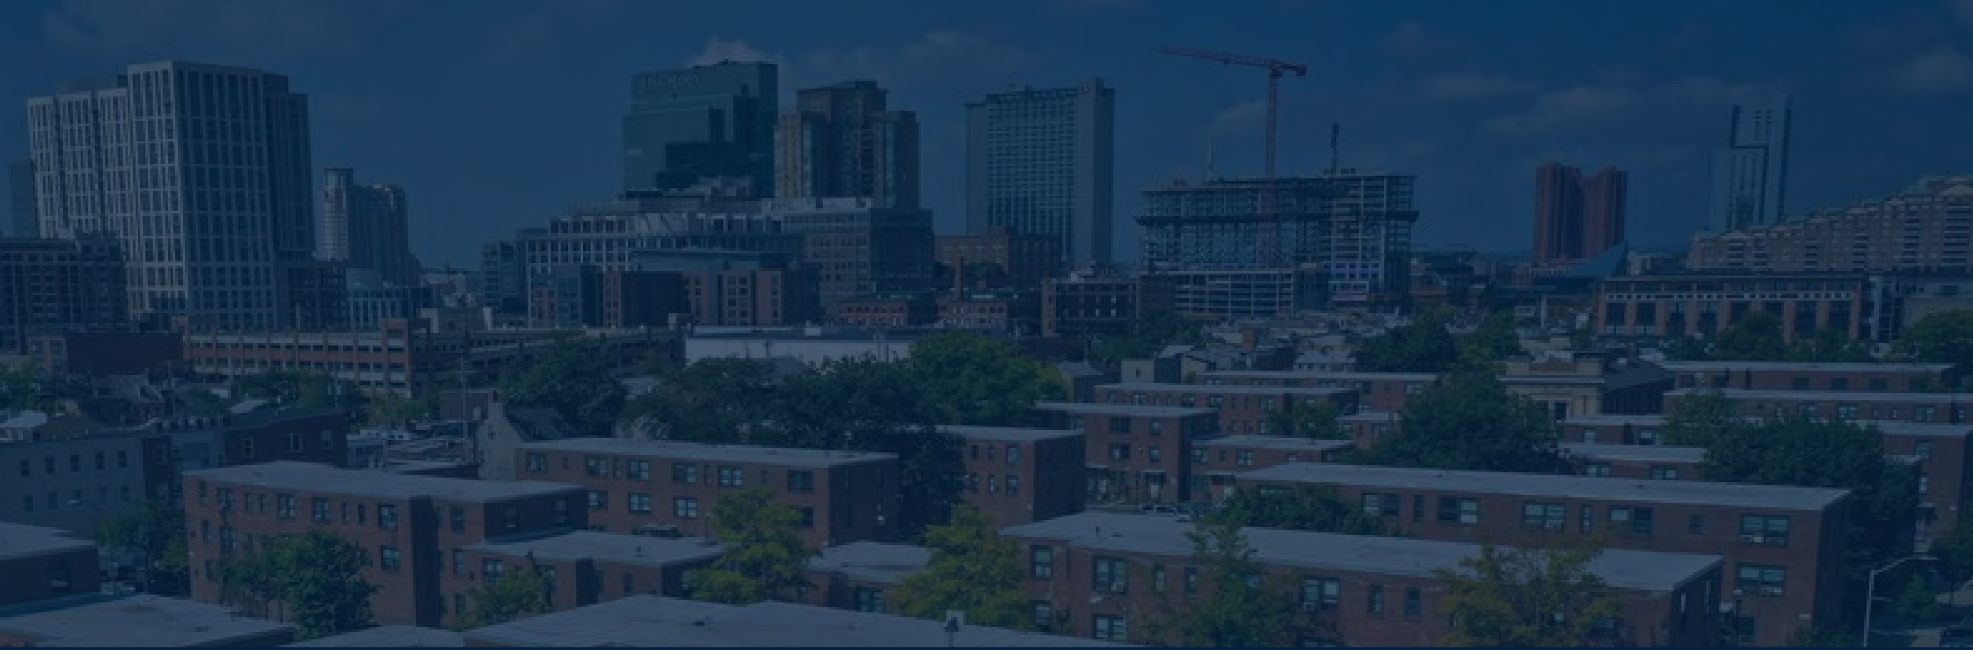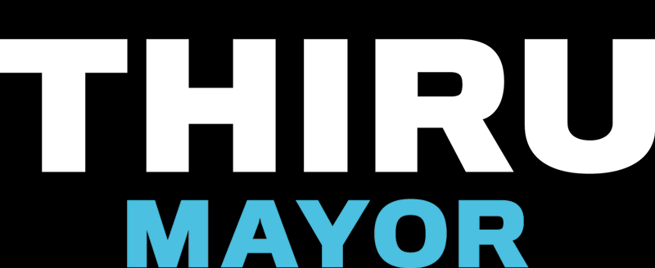

LEGALIZING CANNABIS IN BALTIMORE

The marijuana marketplace in Baltimore is currently a chaotic free-for-all. The illegal trade contributes to record violence, and the medical trade is not taxed. Mayoral Candidate Thiru Vignarajah has pledged to make Baltimore the first city in America to regulate and tax marijuana without waiting for federal or state approval.

# Devote Tax Revenue to Public Education Priorities

All City revenue would be directed exclusively to key education programs:  Universal pre-K for every 3- and 4-year-old child

 Debt-free higher education for public high school graduates, including trade school  Funding to grow the endowments of HBCUs

# Establish City Agency to Manage the New Market

Appoint board members who will develop permit criteria; fix taxes and regulations; and issue growth, processing, sale, and “cannabis café” permits

Create a safety board that will ensure recreational cannabis is safe and free of dangerous additives

# Guarantee Access and Equity for Communities of Color

Frustration continues to grow as communities of color—who disproportionately



shouldered the burdens of the failed War on Drugs—are now being effectively excluded

from the profitable new market. Baltimore will

issue

by

permits preferentially to

enterprises

owned,

operated,

and

controlled

historically-disadvantaged

minorities and those who commit to hire returning citizens with non-violent criminal

records seeking constructive employment.

Establishing a legal cannabis market in Baltimore would

produce $250 million in annual revenue for the City.



**Reduce Crime, Create Jobs & Increase Investments in Education**

**by Regulating and Taxing Baltimore’s Marijuana Market**

*Mayoral candidate Thiru Vignarajah announced a bold plan to issue permits and tax the cannabis trade in Baltimore to reduce crime, create well-paying jobs, reduce overdoses, and fund universal pre-K for every Baltimore child.*

The marijuana marketplace in Baltimore is currently a chaotic free-for-all. The illegal trade contributes to record violence while depriving taxpayers of hundreds of millions of dollars. The illegal street market operates unimpeded as police and prosecutors publicly squabble about whether to enforce current laws, even as street marijuana is increasingly laced with fentanyl and K-2. Medical cannabis is booming but cannot be taxed and has virtually no licensed distributors of color.

Bottom line: a billion dollars is spent on cannabis products each year, which largely ends up in the monopoly hands of untaxed licenses and violent gangs and drug organizations.

This is the worst of all worlds. Violence is unabated; avoidable overdoses persist; and drug proceeds remain locked in a violent black market. Moving the cannabis trade into a well-regulated, transparent market and out of the shadows will (1) reduce gun violence driven by competing gangs, (2) decrease overdose deaths from laced marijuana, (3) reduce opioid addiction and overdoses; (4) mitigate the racial wealth gap, and (5) provide vital revenue to fund universal pre-K, finance repairs and upgrades at K-12 school facilities, guarantee free college in Maryland for public school graduates, and grow HBCU endowments. Baltimore City cannot afford to wait for indecisive lawmakers in Annapolis to take action while the City suffers from the failed war on drugs.

Just as Colorado and other states have issued permits and taxed the sale of cannabis, even though it remains illegal under federal law, so too should Baltimore City issue sales permits and tax cannabis. The same people who think Baltimore City has to wait for Maryland law to change thought Colorado had to wait for federal law to change. It’s time for Baltimore to lead, not follow.

**Issue Permits to Baltimore Businesses to Aid Communities of Color**

When it comes to marijuana, the war on drugs has been a colossal failure. For decades, communities of color have disproportionately shouldered the costs of Baltimore’s enforcement policies. The communities who were most devastated by the failed policies of the 1980s ought to be the first to benefit from this emerging market.

* Permits will be preferentially issued to enterprises owned, operated, and controlled by historically disadvantaged business owners of color.
* Permits will be issued to distributors owned, operated, and controlled by local businesses.
* Permits will be preferentially issued to enterprises who commit to hire employees with non- violent criminal records who are seeking legitimate employment opportunities.

**Require Tax Proceeds be Spent Strictly on Public Education Programs**

The emerging cannabis market would produce $250 million in annual revenue for Baltimore City. Maryland and neighboring states will inevitably legalize marijuana, but there is a first-mover advantage in this industry that the City should seize. In the past, residents have been promised funds for education from controversial ventures like casinos only to see money diluted or redirected to other priorities. This won’t happen again.

* All cannabis tax proceeds will be strictly dedicated to key education programs, starting with

(1) universal pre-K for every 3- and 4-year-old child, (2) repairs and improvements at K-12 facilities, (3) debt-free 4-year college, community college, or trade school for Baltimore public high school graduates, and (4) funding to grow the endowments of HBCUs.

* These funds will be used only to support new programs and to supplement, not replace, current funding sources for the expansion of existing programs.

**Establish Infrastructure to Manage Complex Emerging Market**

* The City will establish a commission composed of community members, with no conflicts, who will manage and make permitting decisions. The process and decision-making will be fully public and transparent so there are no doubts who made the decision and why.
* The City will create a city-operated credit union that holds the proceeds of cannabis sales, collects taxes and distributes them immediately to vital education programs, and eventually makes its reserve funds available for low-interest student and small business loans.
* The City will create a safety board that will ensure that recreational cannabis is safe and free of dangerous additives like fentanyl and will create and communicate clear regulations about when, where, and how the product can be sold and used.

In theory, in states like Colorado, prosecutors could bring charges under federal drug laws anytime. In practice, they never have. The premise of the proposed approach is that prosecutors in Baltimore have better things to do with their time than to go after permitted, minority-owned cannabis dispensaries based in Baltimore who hire residents desperately trying to obtain legitimate employment to turn their lives around. Issuing city permits and collecting taxes would no more make the sales legal under state law than issuing state licenses makes the sales legal under federal law. But, with ingenuity and leadership, we can still bring the marijuana trade out of the dangerous shadows—where gangs kill over turf—and create a safer market that redresses racial inequities and generates massive tax revenue at a time when Baltimore desperately needs it.

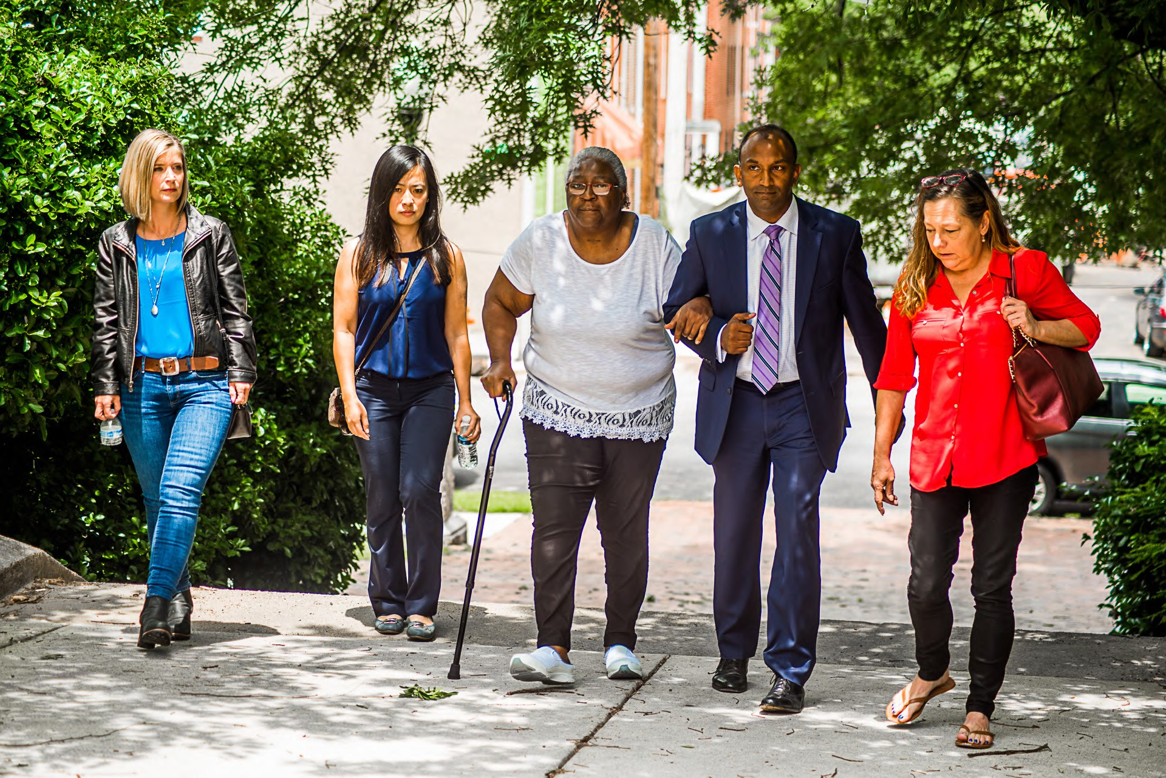

Backing Baltimore's Businesses

If Baltimore is to become the city it’s destined to be, the backbone of its economy must be small businesses. Here are Thiru's key priorities and concrete ideas to foster a welcoming, sustainable environment where businesses can thrive today and tomorrow...

#### Guarantee Public Safety

Create a safe and secure atmosphere around businesses by ensuring sufficient public and private policing

Reduce crime around businesses by providing incentives to purchase, install, and register cloud-based security cameras

#### Reduce the Costs of Doing Business in Baltimore

Cut property taxes in half over a period of ten years End minor privilege and permitting fees

Expand free parking near shops and restaurants Introduce low-interest rainy day loans for small businesses

#### Encourage Entrepreneurship, Diversity & Innovation

Pledge health insurance coverage for up to seven employees for companies that stay in Baltimore for at least five years

Recruit small businesses with a national marketing campaign

Provide tax incentives to encourage growth of small businesses owned and operated by minorities, women, members of LGBTQ and immigrant communities

YOUR DREAM HOME IS

WAITING FOR YOU.

LOCATED AT 2749 CONIFER DRIVE EVERETT, WA

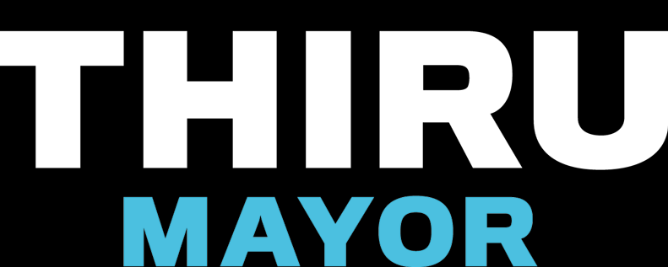

From The Wire to Veep, from the Star Spangled Banner to jazz, Baltimore’s rich history in art, film, and music is a source of pride and engine for growth.

Baltimore has all the promise to once more be a leader in the arts. But building an economy around art, film, and music will not happen on its own. City Hall must play a central role to ignite this industry.

THIRU'S PLAN TO REVITALIZE THE ARTS IN BALTIMORE

Expand and support the creation of additional arts and entertainment districts in addition to Station North, Highlandtown, and Bromo Tower

Extend tax-free income benefits in art districts to cover more artists, including, for example, musicians, spoken-word performers, and filmmakers

Create an "artists in residence" program. Participating artists and musicians would receive healthcare and a stipend in exchange for committing to teach their art in public schools and promote art in Baltimore's communities

Lead a capital campaign to raise funds from private donors in order to reinforce the shaky financial foundation of the Baltimore Symphony Orchestra

Re-establish incentives to encourage television producers and filmmakers to set their works in the city

Launch a mural initiative that matches local artists, potential donors, and community hosts to collaboratively beautify Baltimore